**Qui a dit des trajectoires différenciées selon le genre ? État des lieux de la sédentarité et de l’activité physique tout au long de l’adolescence**

*Thibaut Derigny, Quentin Blanchet, Nathan Bauerlin, Ornella Goldstein, Christophe Schnitzler, François Potdevin, Joseph Gandrieau*

**ABSTRACT**

*Background* : Le manque d’activité physique (AP) et l’excès de comportement sédentaire (SB) sont des problèmes de santé publique, tout particulièrement chez les femmes où ces constats épidémiologiques sont les plus sévères. Le processus de construction de ces différences d’AP entre les filles et les garçons a peu été exploré, notamment lors de la période de l’enfance et de l’adolescence qui est charnière dans l’adoption d’un comportement physiquement actif tout au long de la vie. Ainsi, l’objectif de cette étude est d’évaluer les trajectoires de sédentarité et d’AP des filles et des garçons de la fin de l’enfance à l’âge adulte. *Methods* : Un suivi transversal d’AP est mené auprès de 641 individus (366 garçons, 275 filles). Les participants ont été équipé d’un accéléromètre GT3X pendant 7 jours consécutifs. *Results* : Les trajectoires de SB (+18.7%), de LPA (-16.5%) et de MVPA (-2.2%) ont évolué significativement entre le début et la fin de l’adolescence pour l’ensemble des participants. Seul le taux de MVPA des garçons est toujours significativement plus élevé que celui des filles, que ce soit au début ou à la fin de l’adolescence (children: 7.3% *vs* 5.9%, *p*<.05; young adults: 5.4% vs 4.2%, *p*<.05). Les trajectoires de vie physique sont davantage négatives pour les filles que pour les garçons avec des écarts qui se creusent en SB (+1.6%), LPA (-1.9%) et MVPA (+0.2%). *Discussion* : Cette étude, menées par accélérométrie, précise les études utilisant des questionnaires. Traditionnellement, il est observé des écarts qui se creusent entre les filles et les garçons tout au long de l’adolescence, alors que cette étude amène à un regard moins alarmant sur l’importance unique de cette période pour être physiquement actif tout au long de la vie. Plus que les taux bruts d’AP des filles et des garçons, ces résultats invitent à davantage interroger l’état d’éducation à l’AP.

**METHOD**

*Study design and measurement*

This research recruited volunteer’s children and adolescents at school during physical education lessons, and in sports clubs after school, to participate in a large epidemiological PA cross-sectional assessment in France throughout secondary school (n=641; 194 children, and 447 young adults; 367 men, and 274 women; before inclusion criteria). Participants were randomly selected based on their school level: first year of secondary school for children, last year of secondary school for young adults. A particular attention was according to gender and sociodemographic parities criteria to not impact the distribution of the PA observed (Slootmaker et al., 2009). Inclusion criteria were to be in first or last year of secondary school in France, and to agree to wear an accelerometer for one week. For all recruited participants, sociodemographic data were collected, including age, sex, height, weight, email address and telephone number. Before entering the study, written consent was obtained from all participants and parents/caregivers, if they were under 18 years old. Data collection occurred two years between September 2020 and June 2022. This study was conducted according to the guidelines of the Declaration of Helsinki (2013) and approved by the Ethics Committee of the University of Lille (2020-418-S82), approval May 2020.

ActiGraph accelerometers, model GT3X+ (ActiGraphTM, Pensacola, FL, USA), were used to measure PA with a sampling rate of 30Hz. Participants wore the accelerometer on their preferential hip, fastened with an elastic belt for seven full days (Trost et al., 2005; Vanhelst, 2019). Data were reintegrated using a 10-s epoch. Troiano’s (2007) wear time validation algorithm was applied, associating non-wear time to all periods >60minutes of consecutive counting at zero. For children, the Actigraph output of Evenson (2008) was the cut-offs used to define the level of intensity. For young adults, Freedson’s (1998) calibration was used to determine the cutpoints. A minimum of three weekdays and one weekend day, with valid PA data (≥10 hours per day), was required to be included in the analyses (Cain et al., 2013). Sleep time was excluded.

Figure 1. Flowchart of participants selection

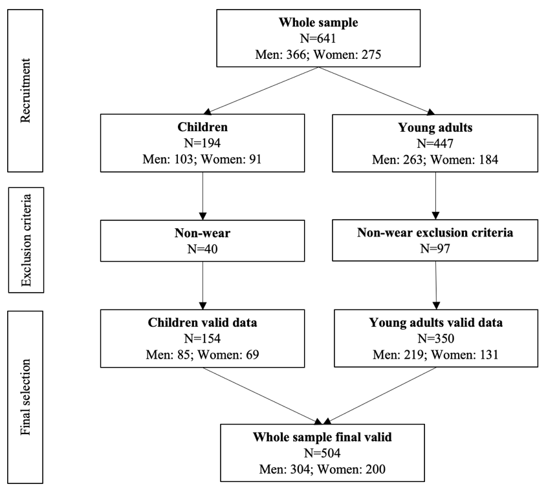

*Statistical analysis*

Statistical analyses were conducted with R software (version 4.1.2), with specific packages (tidyverse, outliers, psych, car, rstatix, ez, Rmisc, ggplot2). Data and residuals of age and wear time for each group (children, and young adults) were tested for normality, interdependence and homoscedasticity using Shapiro-Wilks, Levene and Fisher Snedecor tests. As these preliminary conditions were not met, non-parametric tests on median and interquartile intervals values were used. The threshold of statistical significance was set at 5% (*p*<.05).

First, Chi-squared, and Kruskal-Wallis tests were used to detect groups effects on gender, age, and accelerometers wear time. The second step of analysis consisted of conducting three models of two-way analysis of variance (Time x Gender) to detect any significant main and interaction effects of each independent variable on SB, LPA, and MVPA. Between-group differences (children *vs* young adults; men *vs* women) for the same grade, and within-grades differences were analyzed by Tukey post hoc tests. We calculated Partial Eta squared values (ηp2) and their confidence intervals, to examine effect sizes, considered as small when ηp2>.01, medium when ηp2>.06, and large when ηp2> .14 (Cohen, 1988). Finally, we calculated the evolution of the gender gap throughout the secondary school, by comparing the delta of SB and PA (differences between young adults and children) according to gender (women - men) with series of Wilcoxon rank sum test for independent variables.

**RESULTS**

*Participants characteristics*

Following inclusion and exclusion criteria, a whole sample of 504 children and young adults were including in this study (154 children, agemean=9.44±1.59; 350 young adults, agemean=17.0±1.18). The diagram flowchart and characteristics of the study sample are respectively presented in Figure 1 and Table 1. The comparison inter-groups revealed that young adults were more numerous than children (χ2(2)=13.756, *p*<.05, η2p=.03, small), they are logically older (χ2(1)=346.26, *p*<.05, η2p=.69, large), and they have worn the accelerometer significantly longer than children (χ2(1)=94.768, *p*<.05, η2p=.19, large), as is often the case in this type of epidemiological study (REF). To limit this bias, analysis is focused on the percentage of time past in SB, LPA and MVPA.

Table 1. Description of participants characteristics

|  |  |  |  |  |  |  |  |
| --- | --- | --- | --- | --- | --- | --- | --- |
|  | **Children** | | | **Young adults** | | | ***p*-value** |
| *Whole sample* | *Men* | *Women* | *Whole sample* | *Men* | *Women* |
| N | 154 | 85 | 69 | 350 | 219 | 131 | <.05 |
| Age | 9.44±1.59 | 9.16±1.65 | 9.78±1.46 | 17.0±1.18 | 16.9±1.38 | 17.1±0.78 | <.05 |
| Wear time | 5473 [1628] | 5603 [1574] | 5282 [1619] | 10180 [4587] | 10180 [4501] | 9656 [5093] | <.05 |

*Evolution of physical activity intensities throughout secondary school*

Results from the two-way ANOVA on SB and the two PA intensities (LPA and MVPA) are presented in Table 2 and Figure 2, which shows median of percentage values by Time (children *vs* young adults) and Gender (Whole sample *vs* Men *vs* Women). Gender effects are only identified for MVPA where boys have always a higher level of education than girls (children: 7.3% *vs* 5.9%, *p*<.05; young adults: 5.4% vs 4.2%, *p*<.05). Time effects are identified for SB, LPA, and MVPA. For whole sample, Posthoc results have shown a significant upward trajectory of SB throughout secondary school (+18.7%, from 65.8% to 84.5%, *p*<.05), while intensities of LPA (-16.5%, from 27% to 10.5%, *p*<.05), and MVPA (-2.2%, from 6.8% to 4.6%, *p*<.05) decrease significantly.

These trajectories (Table 3) had similar patterns for girls and boys, with an increase in SB throughout secondary school (men: +18%, from 66.1% to 84.1%, *p*<.05; women: +19.6%, from 65.7% to 85.3%, *p*<.05), a decrease of LPA (men: -15.4%, from 25.9% to 10.5%, *p*<.05; women: +17.5%, from 27.9% to 10.4%, *p*<.05), and MVPA (men: -1.9%, from 7.3% to 5.4%, *p*<.05; women: -1.7%, from 5.9% to 4.2%, *p*<.05). No interaction effect is identified (Gender x Time).

Table 2. *Effects of gender and time on sedentary behaviour and physical activities levels*

|  |  |  |  |  |
| --- | --- | --- | --- | --- |
| **Variables** | | **SB** | **LPA** | **MVPA** |
| Children | *Whole sample* | 65.8% [10.7] | 27% [8.1] | 6.8% [4.3] |
| *Men* | 66.1% [10] | 25.9% [6.3] | 7.3% [4.3] $ |
| *Women* | 65.7% [11.6] | 27.9% [9.3] | 5.9% [4.2] |
| Young adults | *Whole sample* | 84.5% [10.3] * | 10.5% [7.4] * | 4.6 % [4.1] * |
| *Men* | 84.1% [13.8] * | 10.5% [6.7] * | 5.4% [5.1] * $ |
| *Women* | 85.3% [9.1] * | 10.4% [8.6] * | 4.2% [3.3] * |
| Gender effect | | NS | NS | F(1,500)=19.18, *p*=1.45e-05, ηp2=0.04 |
| Time effect | | F(1,500)=562.63, *p*=6.86e-84, ηp2=0.53 | F(1,500)= 945.41, *p*=2.45e-117, ηp2=0.65 | F(1,500)=32.71, *p*=1.85e-08, ηp2=0.06 |
| Gender x Time effect | | NS | NS | NS |

*: time significant effect; $: gender significant effect; NS: non-significant; SB: sedentary behaviour; LPA: low physical activity; MVPA: moderate and vigorous physical activity.

Table 3. *Trajectories of sedentary behaviour and physical activities according to gender*

|  |  |  |  |  |
| --- | --- | --- | --- | --- |
| **Variables** | | **SB** | **LPA** | **MVPA** |
| Trajectories | *Whole sample* | +18.7% | -16.5% | -2.2% |
| *Men* | +18% | -15.4% | -1.9% |
| *Women* | +19.6 | -17.5% | -1.7% |
| Trajectory difference Women *vs* Men | | +1.6% ^ | -2.1% ^ | -0.2% |

^: significant differences between men and women; NS: non-significant; SB: sedentary behaviour; LPA: low physical activity; MVPA: moderate and vigorous physical activity.

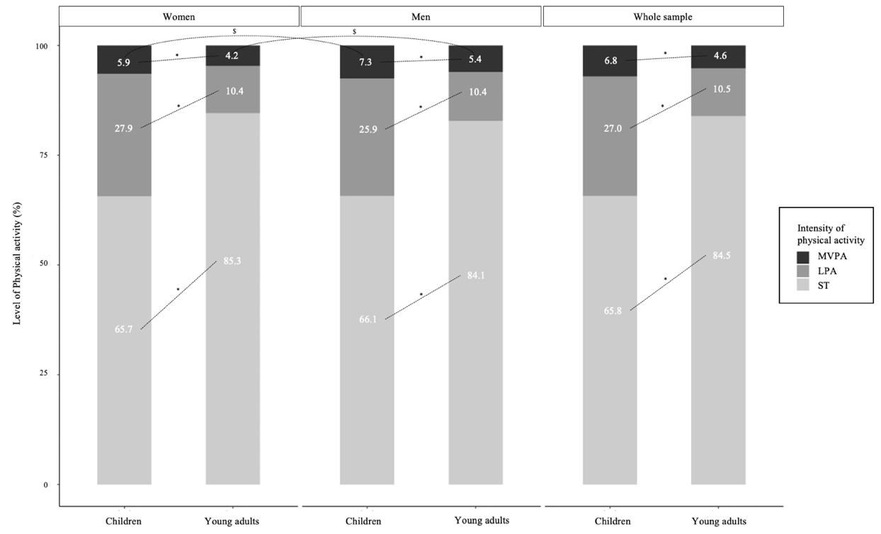

Figure 2. *Sedentary behaviour and physical activities trajectories between children and young adults according to gender and intensities*